Analyzing Alzheimer’s Gene Expression
Abstract
Alzheimer’s disease (AD) is characterized by cognitive decline and widespread molecular changes in the brain which makes it a progressive neurodegenerative disorder. In this study, we analyzed microarray expression data to compare gene expression between Alzheimer’s patients and healthy controls. Three genes of interest: IL17C, TEK, and CCL4 were selected as they cause inflammation and damage vascular function, two major pathways strongly associated with AD pathology. Mean expression values and fold changes were calculated across control (CDA) and Alzheimer’s (PDA) samples. All three genes illustrate increased expression in AD, with CCL4 demonstrating the strongest upregulation, indicating increased inflammatory response. These findings can be used to highlight early molecular patterns associated with Alzheimer’s disease and support further investigation into immune and vascular dysregulation.
Introduction
Alzheimer’s disease is marked by progressive memory loss, cognitive impairment, and structural brain changes. Alzheimer’s disease can disrupt the immune system in the brain and cause problems with blood vessels which means the brain becomes more inflamed and the blood-brain barrier becomes weaker. This affects how nutrients and oxygen reach neurons. Gene expression profiling helps reveal how these biological pathways are disrupted. This analysis centers on three genes:
- IL17C, an immune-related cytokine
- TEK, a receptor tyrosine kinase involved in vascular stability
- CCL4, a chemokine associated with inflammatory signaling
We aim to identify early transcriptional changes that may contribute to disease progression which can be concluded through comparing expression levels between Alzheimer’s and control samples.
Methods:
Dataset
Microarray dataset: Norm_NR.txt
Samples included:
- CDA = control samples
- PDA = Alzheimer’s samples
Data Processing Steps:
- Loaded dataset into Python using pandas.
- Split the first column into RowID, GeneSymbol, and ProbeID.
- Reorganized columns so gene identifiers appear first.
- Identified control and Alzheimer’s sample columns using prefixes (“CDA” and “PDA”).
- Calculated:
  - Control_mean = average expression across CDA samples
  - Alz_mean = average expression across PDA samples
  - FoldChange = Alz_mean − Control_mean
- Filtered dataset to include IL17C, TEK, and CCL4.
- Generated three tables and one figure.
Results
Table 1. Mean expression values for IL17C, TEK, and CCL4 in control and Alzheimer’s samples.
 | GeneSymbol | Control_mean | Alz_mean
7758 | IL17C | 6.695537 | 6.873259
19102 | CCL4 | 13.094788 | 13.626846
22894 | CCL4 | 13.570006 | 14.077097
28609 | TEK | 5.387521 | 5.689869

All three genes show higher average expression in Alzheimer’s patients compared to controls. CCL4 has the highest meaning expression across both probes, reflecting its strong involvement in inflammatory signaling. TEK shows moderate expression levels, consistent with its vascular‑related function. IL17C shows lower overall expression but still increases in Alzheimer’s samples. Note: CCL4 appears twice because the dataset includes two different probes for the same gene, which is expected and not a duplication error.
Table 2. Fold change values for IL17C, TEK, and CCL4 comparing Alzheimer’s samples to controls.
 | GeneSymbol | FoldChange
7758 | IL17C | 0.177721
19102 | CCL4 | 0.532058
22894 | CCL4 | 0.507091
28609 | TEK | 0.302348

Positive fold change values indicate higher expression in Alzheimer’s patients. CCL4 shows the strongest upregulation across both probes, suggesting increased inflammatory activity associated with Alzheimer’s disease. TEK displays moderate upregulation, while IL17C shows a smaller increase but still follows the same upward trend. These fold‑change values highlight which genes may be most responsive to disease‑related changes.
Table 3. Summary of mean expression and fold change for IL17C, TEK, and CCL4 in control and Alzheimer’s samples.
 | GeneSymbol | Control_mean | Alz_mean | FoldChange
7758 | IL17C | 6.695537 | 6.873259 | 0.177721
19102 | CCL4 | 13.094788 | 13.626846 | 0.532058
22894 | CCL4 | 13.570006 | 14.077097 | 0.507091
28609 | TEK | 5.387521 | 5.689869 | 0.302348
All three genes show higher expression in Alzheimer’s patients, with CCL4 displaying the strongest increase across both probes. TEK shows moderate upregulation, while IL17C shows a smaller but consistent rise. Note: CCL4 appears twice because the dataset includes two different probes for the same gene, which is expected and not a duplication error.
Figure 1. Bar chart of fold change for IL17C, TEK, and CCL4.
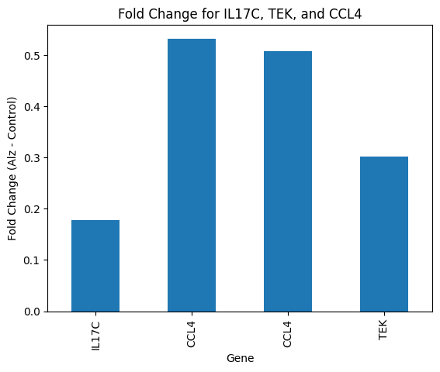
CCL4 shows the strongest increase, TEK shows moderate upregulation, and IL17C shows a smaller rise.
Discussion
The results indicate that IL17C, TEK, and CCL4 are all upregulated in Alzheimer’s disease. CCL4 showed the strongest effect, a chemokine associated with immune activation. This aligns with current research findings that neuroinflammation plays a major role in AD progression. TEK, a vascular-related gene, also showed moderate upregulation, supporting the idea that vascular dysfunction contributes to Alzheimer’s pathology. IL17C, although its regulation was more modest, it still showed increased expression consistent with immune signaling. The presence of two CCL4 probes shows a consistent upregulation that strengthens the reliability of the findings.
Conclusion
This analysis identifies consistent upregulation of IL17C, TEK, and most notably CCL4 in Alzheimer’s samples. These findings indicate the role of inflammatory and vascular pathways in Alzheimer’s disease and these genes may serve as useful starting point for further study. Future work could expand this analysis to additional genes as well.

References
Abed, S., Ebrahimi, A., Fattahi, F., Shekari-Khaniani, M., & Mansoori Derakhshan, S. (2025). Revolutionizing Alzheimer’s Detection: Immune-Related Gene Biomarkers as Non-Invasive Predictors. Molecular Neurobiology, 62(9), 11517–11528. https://doi.org/10.1007/s12035-025-04970-x
https://ftp.ebi.ac.uk/biostudies/fire/E-MTAB-/094/E-MTAB-6094/Files/Norm_NR.txt
Python for Biologists

